1.7

1)  
CREATE TABLE fine(  
fine_id INT PRIMARY KEY AUTO_INCREMENT,  
name VARCHAR(30),  
number_plate VARCHAR(6),  
violation VARCHAR(50),  
sum_fine DECIMAL (8,2),  
date_violation DATE,  
date_payment DATE  
)  
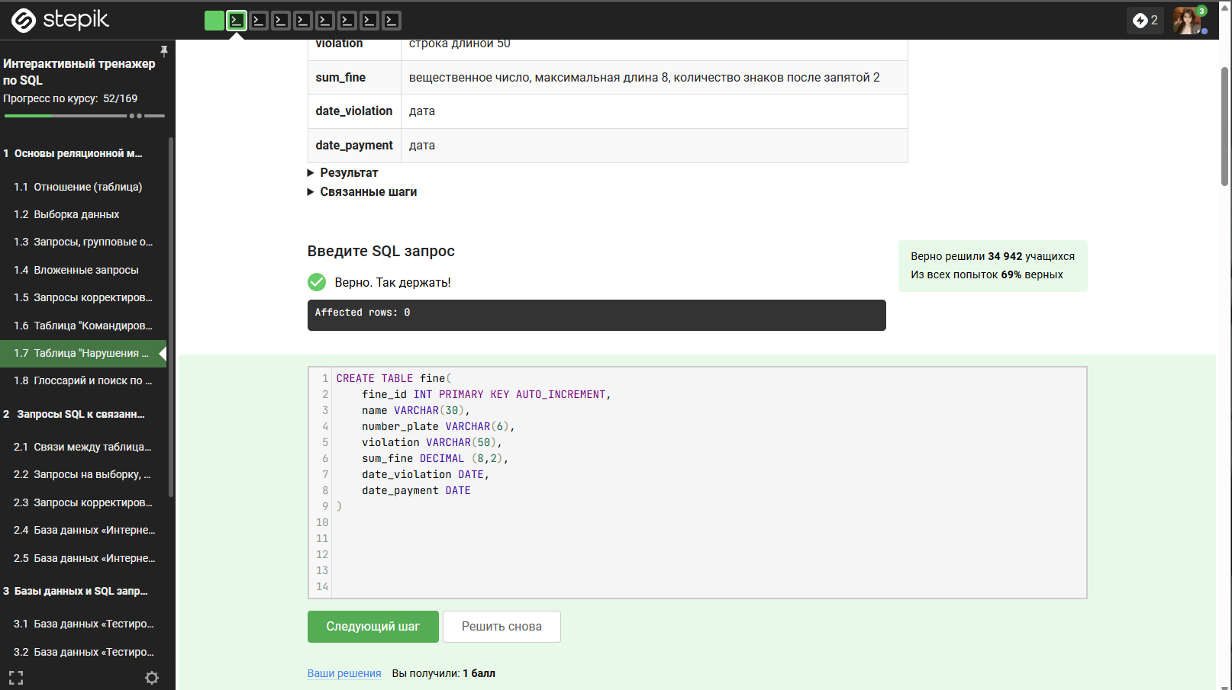

2)  
insert into fine (name,number_plate,violation,sum_fine,date_violation,date_payment)  
values  
('Баранов П.Е.', 'Р523ВТ', 'Превышение скорости(от 40 до 60)', NULL, '2020-02-14', NULL),  
('Абрамова К.А.', 'О111АВ', 'Проезд на запрещающий сигнал', NULL, '2020-02-23', NULL),  
('Яковлев Г.Р.', 'Т330ТТ', 'Проезд на запрещающий сигнал', NULL, '2020-03-03', NULL);  
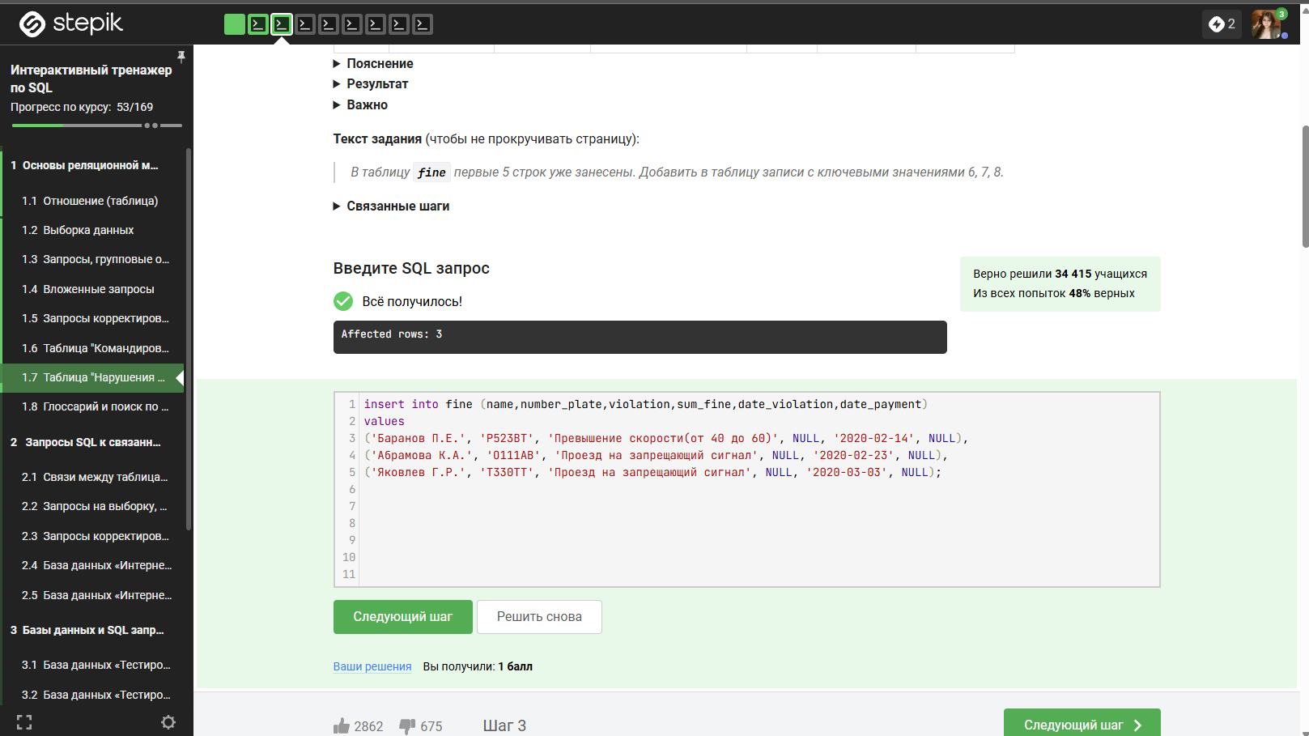

3)  
update fine f  
join traffic_violation t on f.violation = t.violation  
set f.sum_fine = t.sum_fine  
where f.sum_fine is null  
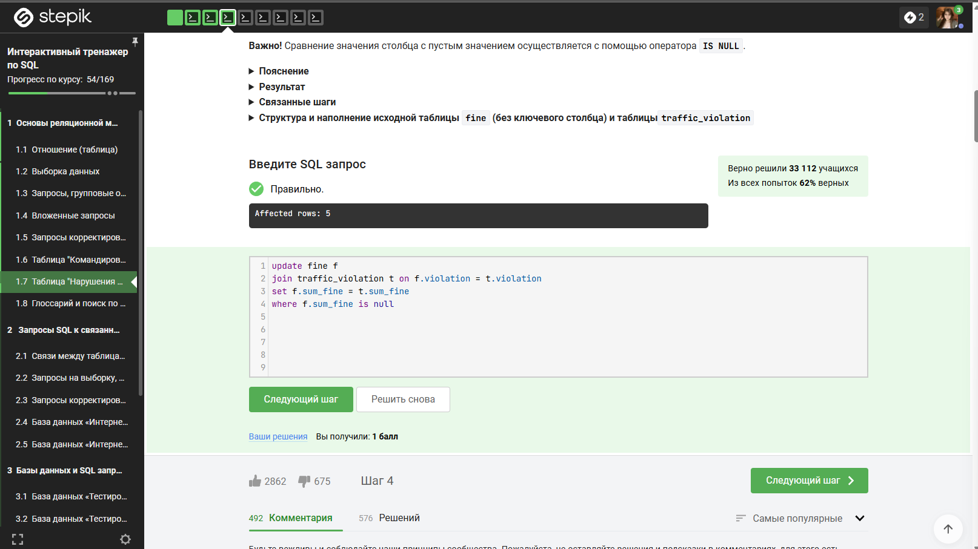

4)  
SELECT DISTINCT  
f.name,  
f.number_plate,  
f.violation

FROM   
fine f  
JOIN (  
SELECT   
name,   
number_plate,   
violation  
FROM   
fine  
GROUP BY   
name,   
number_plate,   
violation  
HAVING   
COUNT(*) >= 2  
) AS repeated ON f.name = repeated.name   
AND f.number_plate = repeated.number_plate   
AND f.violation = repeated.violation  
ORDER BY   
f.name ASC,  
f.number_plate ASC,  
f.violation ASC;  
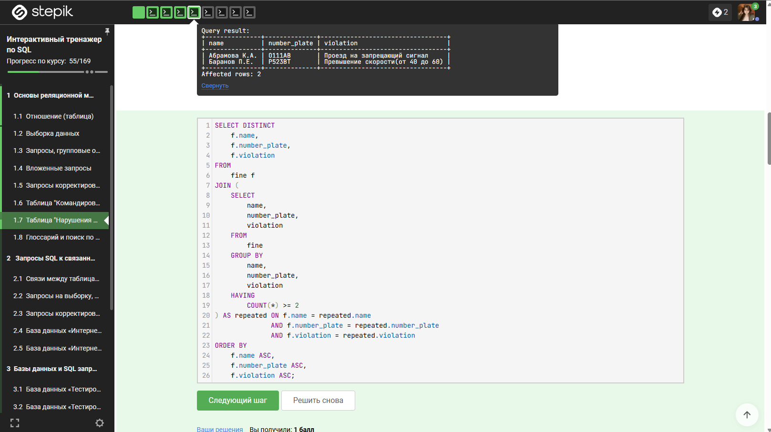

5)  
update fine f  
join (  
select name,   
number_plate,   
violation  
from fine  
group by name,   
number_plate,   
violation  
having   
count(*) >= 2  
) as r on f.name = r.name  
AND f.number_plate = r.number_plate   
AND f.violation = r.violation  
set f.sum_fine = sum_fine * 2  
where f.date_payment is null  
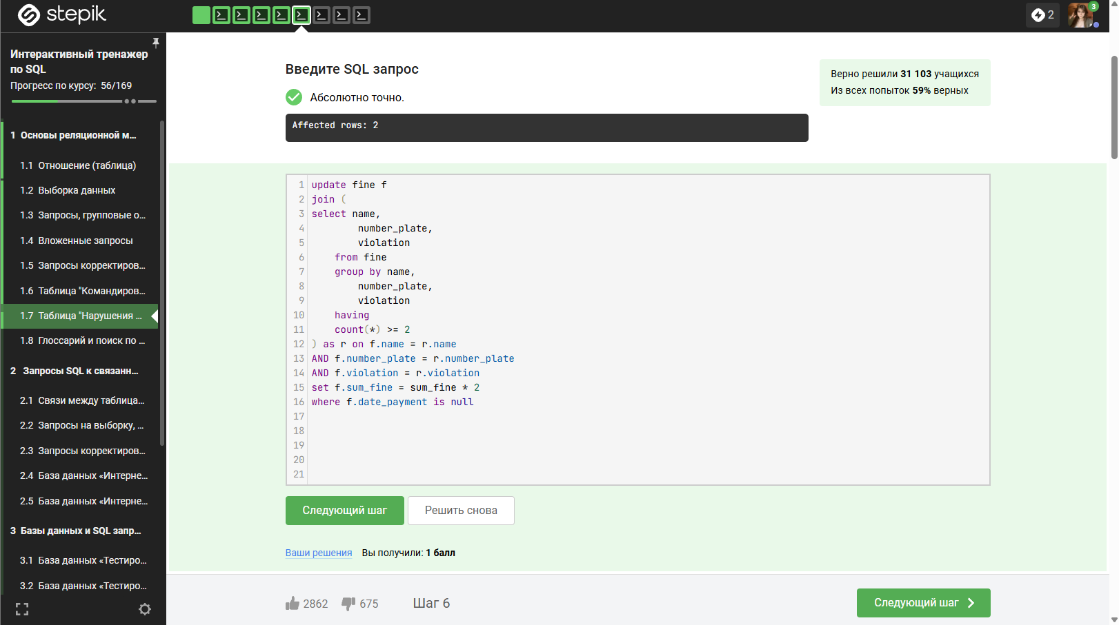

6)  
UPDATE fine f  
JOIN payment p ON f.name = p.name  
AND f.number_plate = p.number_plate  
AND f.violation = p.violation  
and f.date_violation = p.date_violation  
SET   
f.date_payment = p.date_payment,  
f.sum_fine = CASE   
WHEN DATEDIFF(p.date_payment, f.date_violation) <= 20   
THEN f.sum_fine / 2   
ELSE f.sum_fine   
END;  
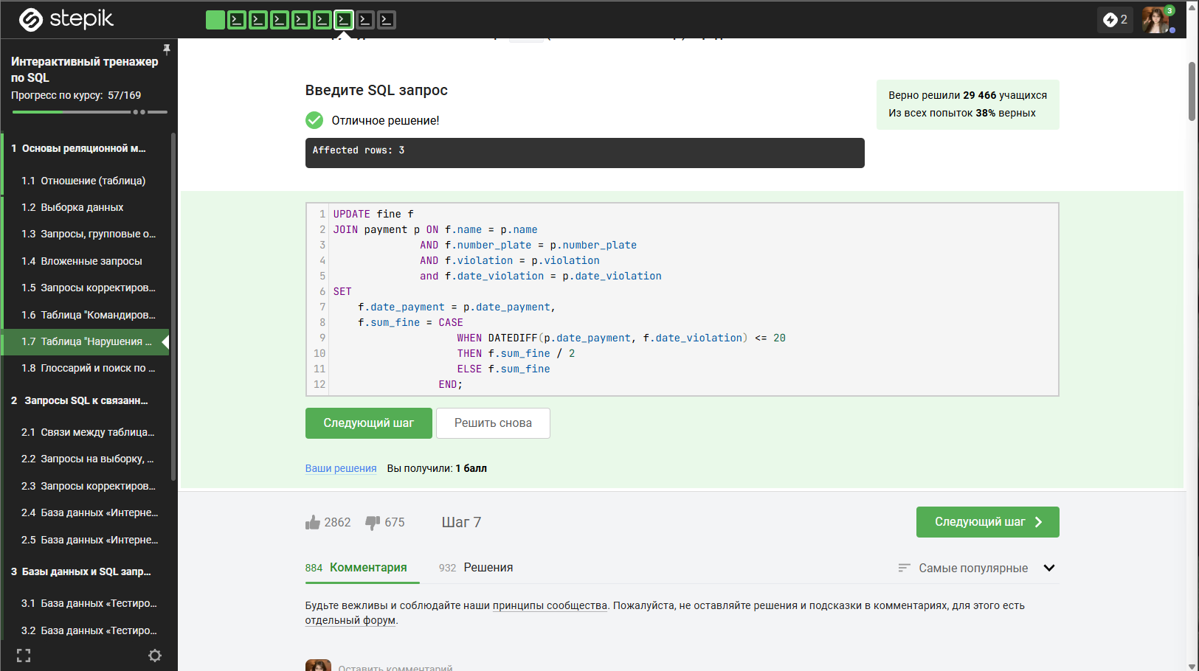

7)  
CREATE TABLE back_payment as  
SELECT name  
,number_plate  
,violation  
,sum_fine  
,date_violation  
from fine  
where date_payment is null  
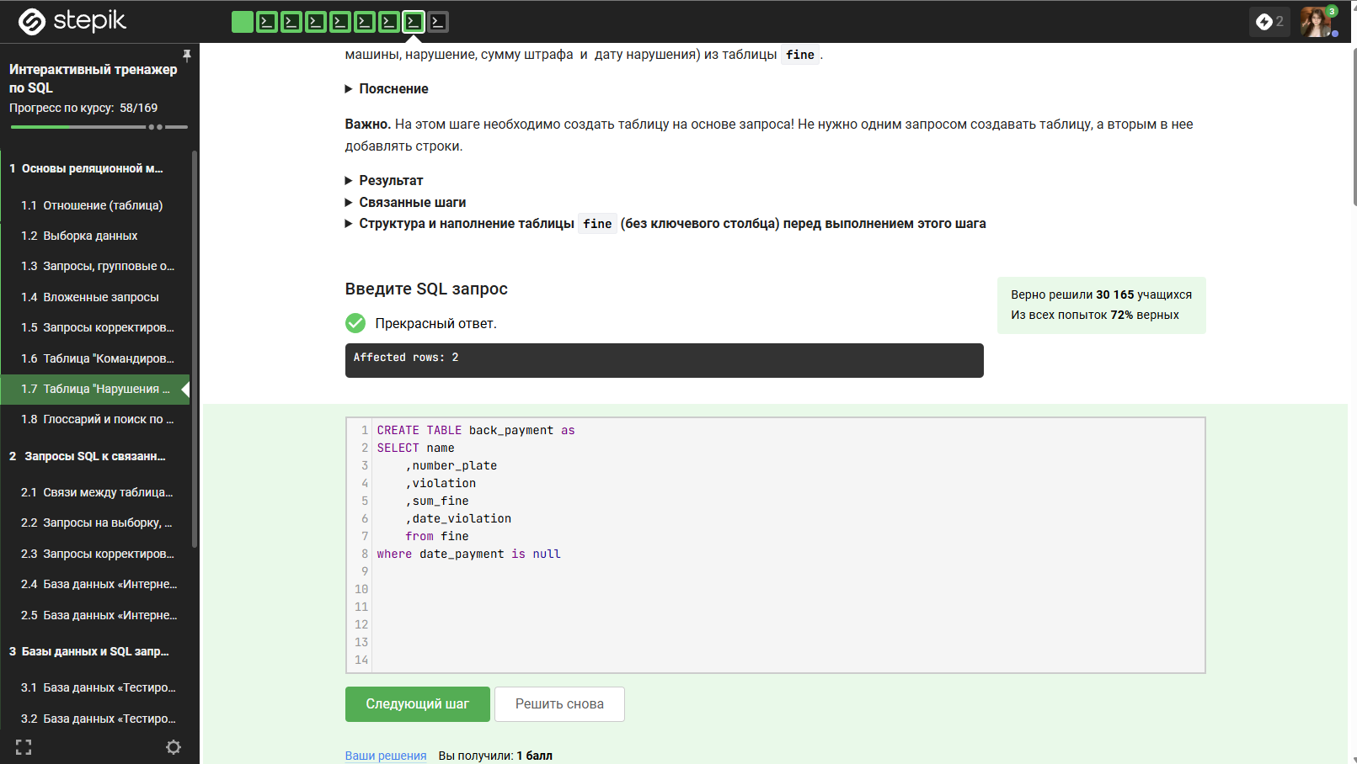

8)  
delete from fine  
where date_violation < '2020-02-01'  
